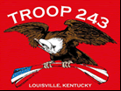
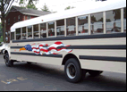
TROOP 243
August 1st, 2011
Boy Scouts of America
Chartered by St. Barnabas Catholic Church

3044 Hikes Lane Louisville, Ky 40220
http://www.troop243.com

Troop 243 Outings & Activities – August starts off with our troop’s annual planning session in which scouts and adults gather to decide what we will do in the coming year. We encourage everyone to come and bring your ideas. We will then have officer elections during which we will choose the new Senior Patrol Leader. The annual Flaget Trail rolls around and is held right here in Louisville this year. We wrap up the month with our 42nd anniversary Court of Honor. Given that we finished up a successful summer camp and our boys have been busy with rank advancements, there should be plenty to celebrate!

Troop and Patrol Meetings on Wednesdays - All are welcome. Scouts in Field/Class A uniforms are expected. Except where noted, all meetings are held at St. Barnabas.

August 3, 7:00 PM – Troop Meeting – Topic is backpacking - service patrol is Cobras
August 10, 7:00 PM – Patrol Meetings
August 17, 7:00 PM – Troop Meeting – Topic is backpacking – The service patrol is Deer Tics
August 24, 7:00 PM – Troop Meeting cancelled because of Court of Honor on Saturday
August 27, 4:00 PM Time Approximate – Troop 243 42nd Anniversary Court of Honor Class A’s expected for the Court of Honor
August 31, 7:00 PM - Troop Meeting – Topic is Eagle Advancement – Service Patrol is Phoenix

Flaget Trail – Every year he Catholic Committee on Scouting organizes tours of some of our area’s historic Catholic churches. This year it is being held here in Louisville. The sites scheduled for visits are, The Passionist Seminary Sacred Heart, St. Agnes Church, Our Lady of Peace Hospital, Bellarmine University Chapel and Calvary Cemetery. You do not have to camp in order to participate but please be aware that parking for day hikers is separate from campers and day hikers and campers will depart for the tour from different places. This trip is not limited to members of the Catholic Church and is more of history of each site and its relationship to the community rather than a history of the Catholic Church itself. Come one come all! This is a great family event.

Troop 243 Annual Planning Meeting – August 27th at 1:00 we will get together to plan for the upcoming year, starting in September. St. Barnabas is the site and we will discuss virtually every aspect of the program for the coming year. Planning will include topics of troop meetings, dates for camp outs, camp out destinations and pretty much anything else that surfaces. All leaders and possible leaders are expected to attend but everyone in the troop is encouraged to attend. Pizza will follow.

Troop Leadership meetings – The troop’s PLC, with new leadership, will be held on August 28th. The August Adult leadership meetings will be held from 7-9 pm August 29th.

Troop Gift Cards – Transportation to the vast majority of our outings is free to our scouts and leadership, but it is not free. The cost of maintenance, fuel and insurance for our busses is paid by the Friends of Troop 243. The Kroger and Thorntons gift card programs fund Friends of Troop 243. We encourage all parents; members, relatives and friends to use Troop 243’s Kroger and Thorntons gift cards. Whenever you see Frank Hulsman at any function please stop him and ask him for one or both of these cards and he will be glad to give you one.
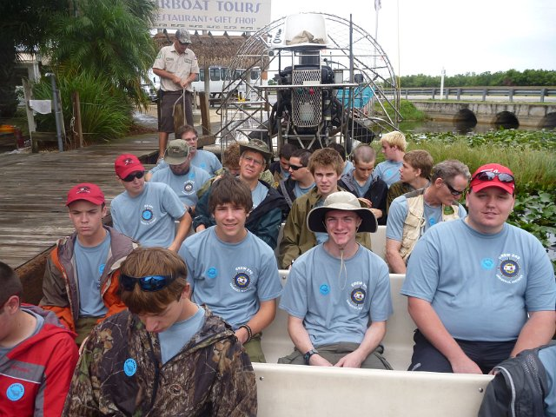
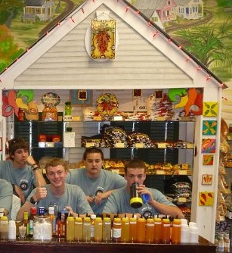
Sea Base Adventurers Return!
By Ruairi Williamson
On June 28th, 2011 six Boy Scouts from Troop 243 and ten Venture Scouts from Crew 243 of St Barnabas and six adult leaders went to Florida National Seabase in the Florida Keys. It was a long, long trip. We boys traveled in our new Scout mini bus with Scout Master Joe Lynch and Assistant Scout Leader Frank Hulsman taking turns at the wheel, while the other adults followed in a truck. We spent the first night of our trip at a Boy Scout camp near Valdosta, Georgia. We spent the second night of our trip at John Pentacamp state park in the Florida Keys. The mosquitoes were the worst things about our whole trip. Even with 75% deet those mosquitoes ate us alive. On the third day together we went on an airboat ride in the Everglades. We saw alligators, turtles and birds and had a fun time on the airboats. Then we spent that night at Pentacamp again. More mosquitoes!
The next day five of us boys and two adults boarded a sailboat called the Juan Cadiz. Six members of the venture crew went sailing on a boat called the Jewel of Athena. The other venture Crewmembers and Zach Shumate, the other troop member, all went scuba diving. We got to sleep on the boat every night. It was much better than with the mosquitoes at the campsite. We went snorkeling over coral reefs and shipwrecks. One day we went to Seabase and spent the day playing volleyball, open sea kayaking, tubing, and small boat sailing. We swam up to the beach for the fourth of July. When we watched the fireworks, our boat was anchored 100 feet from the fireworks barge so we saw the display from up close.
Before I knew it we were headed back to Kentucky. But on the way back the alternator of our bus broke. It took almost a whole day to fix so we had to sleep behind a CiCi’s pizza in Orlando, FL. After Cici’s closed for the night they brought us all their extra pizzas!

Above, the Crew prepares to head out on an Airboat tour where they will see a variety of birds as well as Alligators.

Above in this picture, Geoffrey seems to like the salsa while Joseph tries to douse the fire with water. Milk works better!

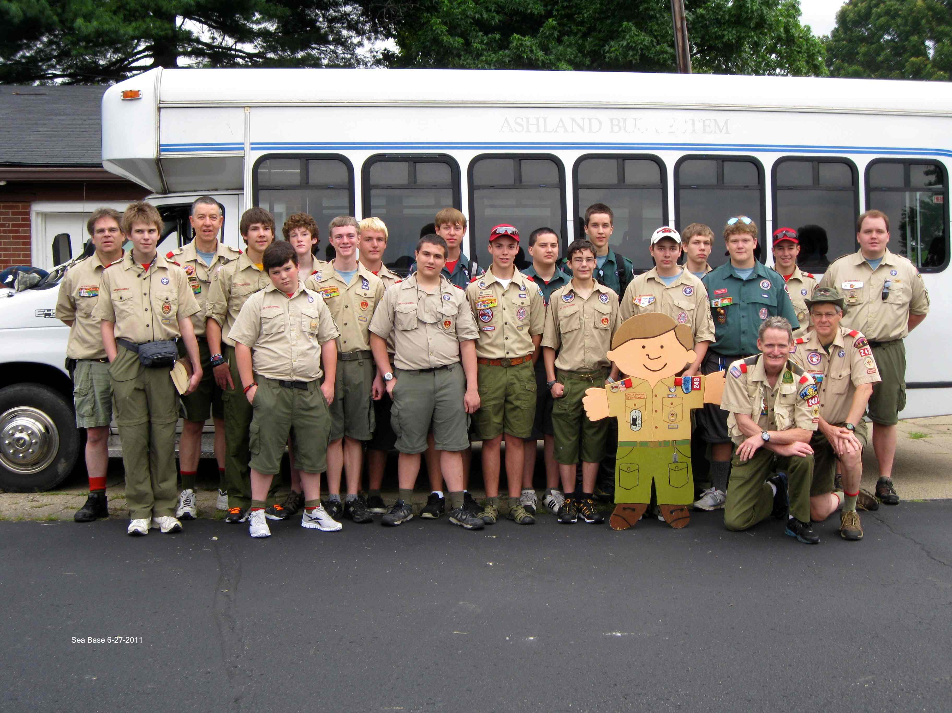
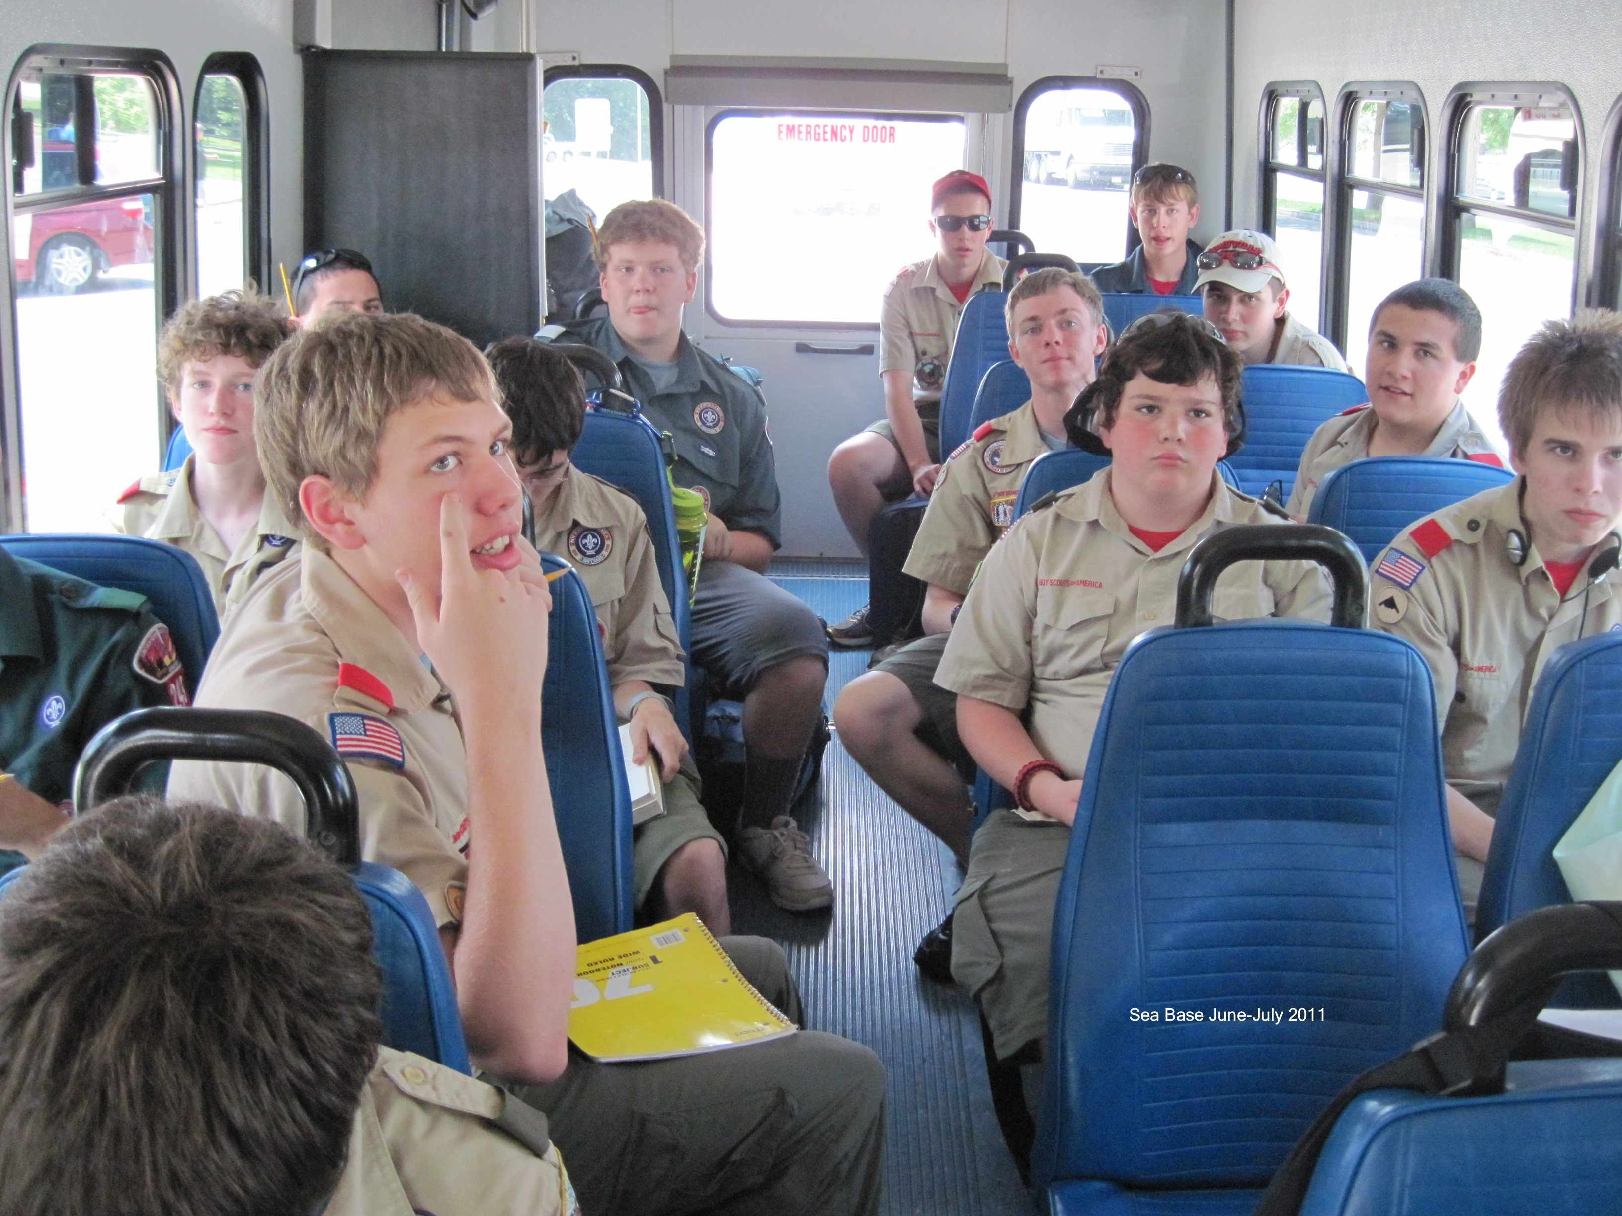

Above, the whole crew is ready to head out the first morning.

Above, the group is on the Troop’s “new” bus heading south. Little do they know that a failed Alternator will add to the adventure.

SCUBA Crew Has Their Own Adventure
Earlier this month I returned from a sailing and scuba expedition to the Florida Keys with my Boy Scout Troop, Troop 243. After a long bus ride down there, we finally arrived at our base in Lower Matecumbe Key, Florida. I was a part of the scuba expedition. Our week consisted of spending lots of time with each other, eating meals at the base’s “galley,” spending lots of time on our dive boat (A 46 foot Newton dive special named the BSA Quail Ridge Explorer), and exploring the depths of the Atlantic Ocean and Gulf of Mexico. While we were at base we resided in dorms there that were quite comfortable, despite being on the 3rd and top floor of the dorm building. We took time out of our days for group prayer, leadership activities, daily chores and other things that helped us to bond as a group.
The best part of this experience, and the main reason we went there in the first place, was the diving. The “depths” we 20-30 feet deep on average; in the Keys, it rarely gets too much deeper than that. We dove at several reefs, both man-made and natural. Some of my favorites were “Alligator Reef,” “Pillars of Atlantis” and “Boink.” We were fortunate enough to get to go on a night dive to Alligator Reef, where we got to see a 10-foot long sea turtle that we were told was about 115 years old! Pillars of Atlantis was a man-made reef that was created when a local bridge (the Channel 5 bridge) was removed and replaced with a more modern bridge in the 1980s. The “pillars” from the channel 5 bridge were removed from their current spot and taken to the place where they currently rest at the bottom of the sea, over the years since they were moved, a reef has grown on them. We went on several very neat dives!
While we were at Sea Base, we got to know each other better. Part of this was due to the “Kodiak” program that we completed while we were there. Kodiak is a leadership program for venture scouting where you learn about communicating with others, problem-solving strategies, and many other things that help embrace good leadership. While there, we also made several excursions off of the base with our dive master. We went to go feed Tarpon (very large and shiny fish), we went to a local museum on the history of diving, and we also went to a local dive shop to see what kinds of things advanced divers put on their Christmas lists. In summary, the Florida Sea Base program is a phenomenal experience in many ways and you get to have experiences there that you might not get to have anywhere else. I strongly encourage getting involved with scouting and taking advantage of this fantastic opportunity. –Cullen Bilyeu

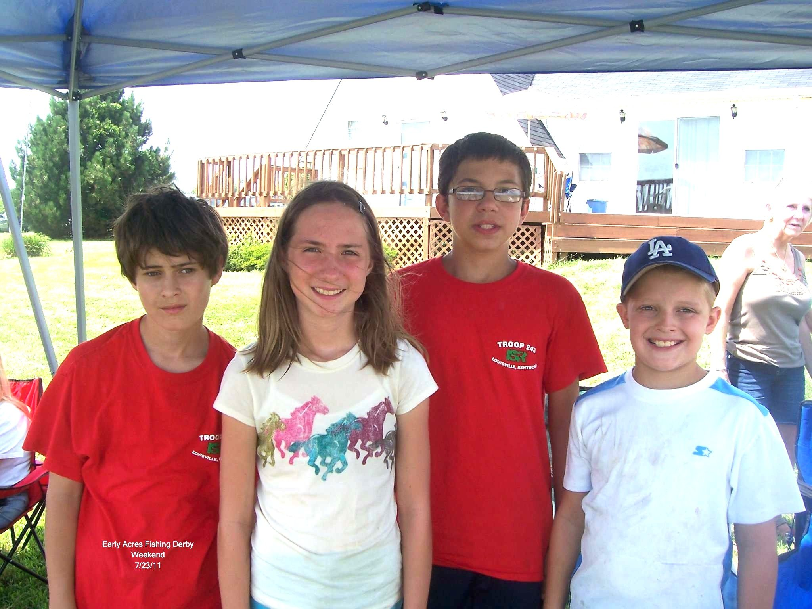
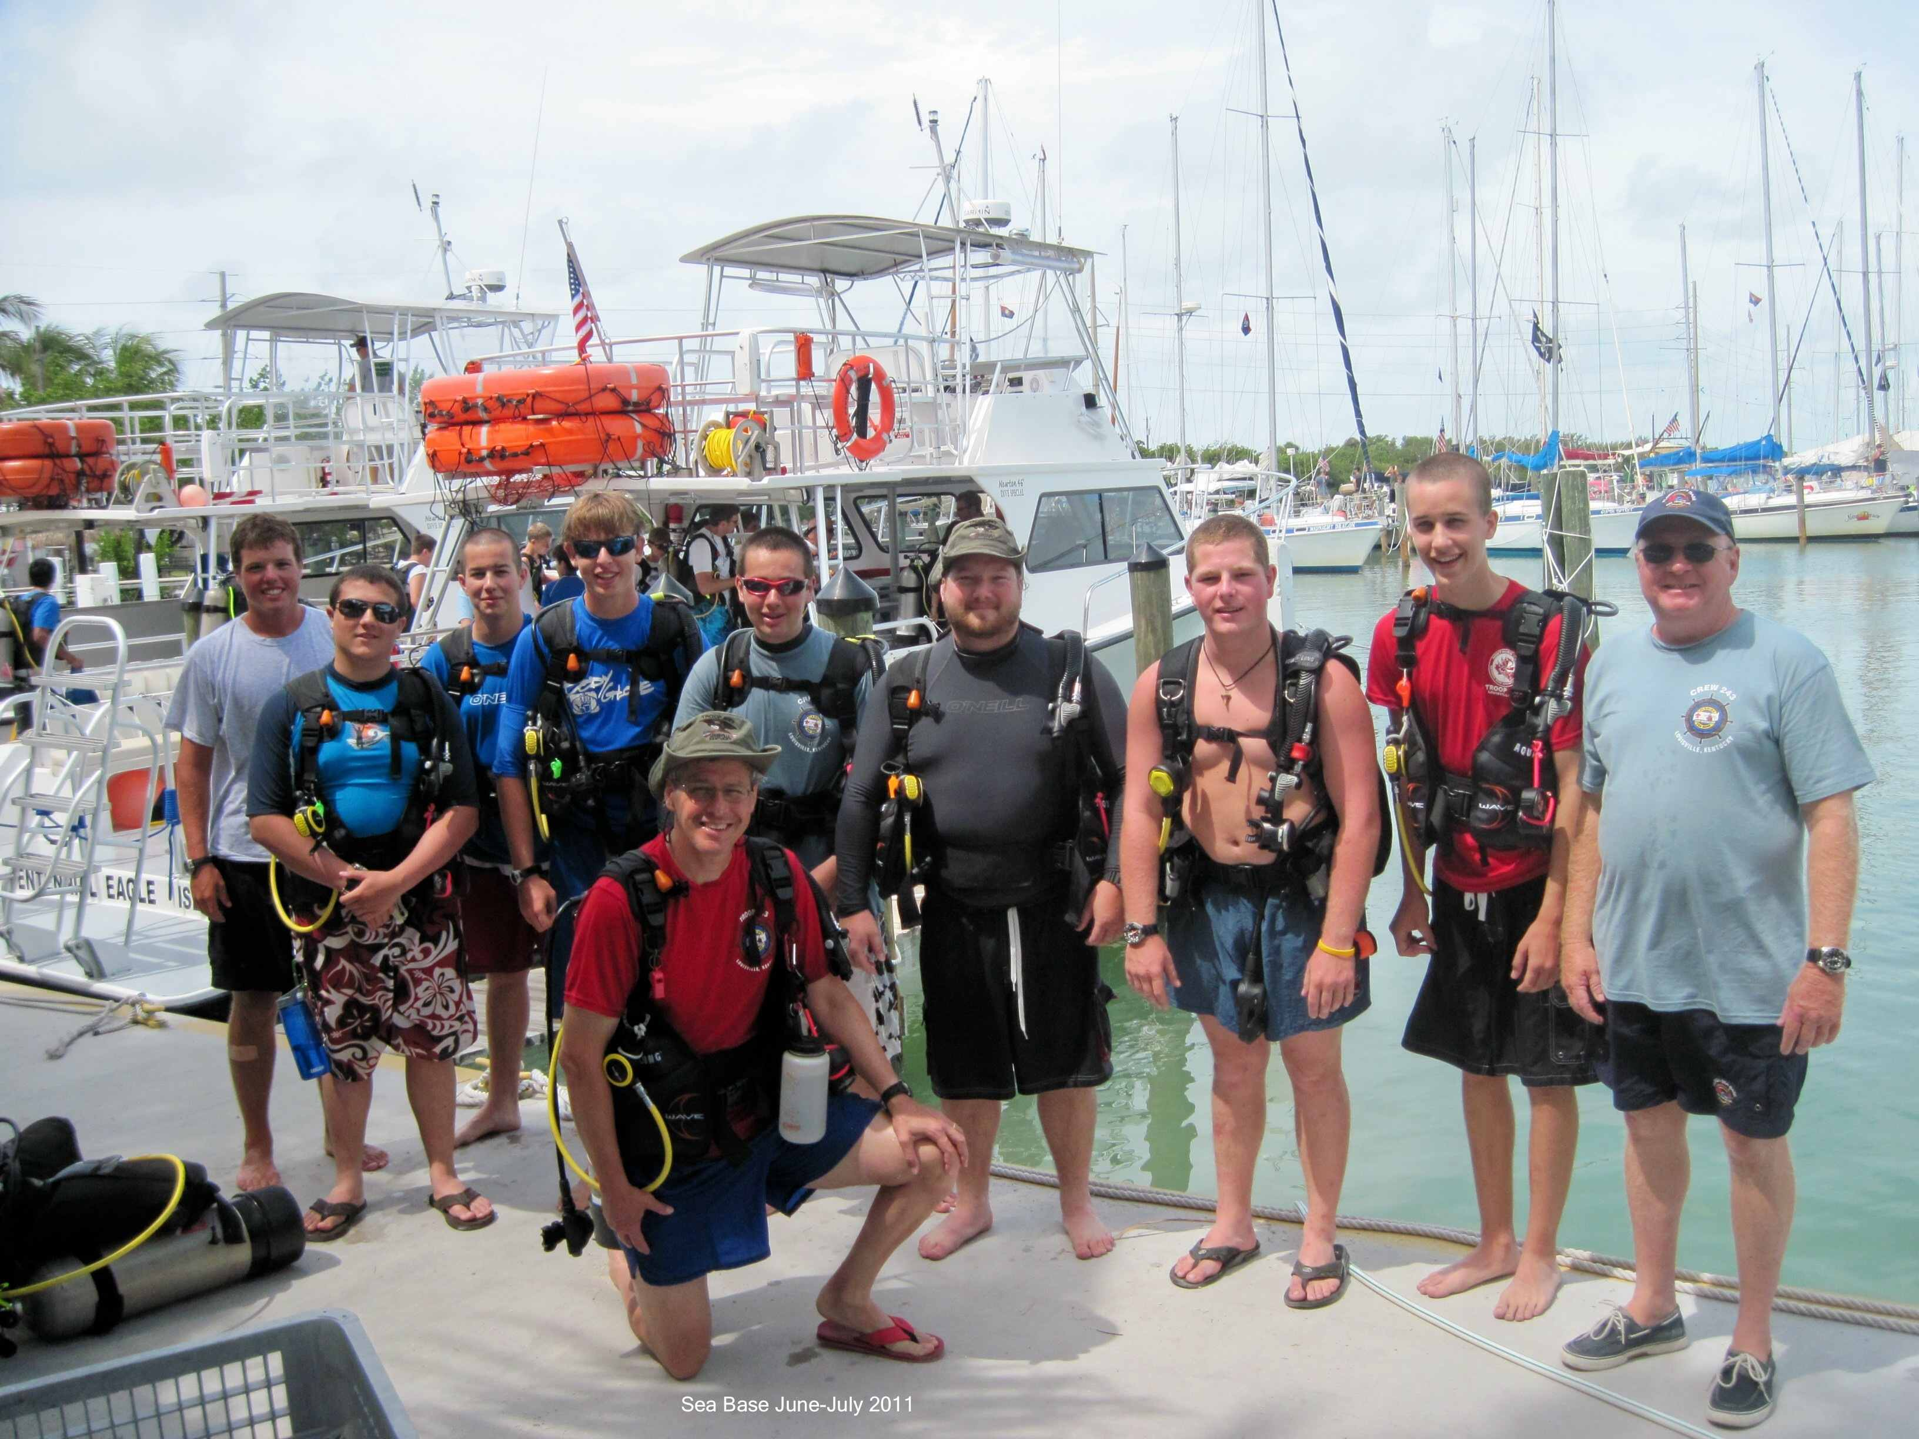
Boys again help with Pack 756 Fishing Derby

Again this month we feature a couple of our scouts who gave of their time to support our John Paul II Academy Cub Scout Pack, Pack 756. Pictured here to the right, Douglas Scarboro, Zach Sheehy and Chris Early acted as judges and chief fish from hook removers for the weekend. Also pictured here, JPII student and Girl Scout, Katy Goens, also helped.
To the left here is the SCUBA crew ready to head out.

